MARKETING AUTOMATION USING CHAT-BOT DEVELOPMENT AND Its DEPLOYMENT ON MAILING SERVER

### AN INDUSTRIAL INTERNSHIP REPORT

*submitted by*

# AVIRAL HARSH (17BCE1076)

*in partial fulfilment for the award of the degree of*

# BACHELOR OF TECHNOLOGY

in

**COMPUTER SCIENCE AND ENGINEERING**



AUGUST 2019



# School of Computing Sciences and Engineering

## DECLARATION BY THE CANDIDATE

I hereby declare that the on-site Industrial Internship Report entitled **“Project Manager & Web Developer”** submitted by me to VIT University - Chennai, in partial fulfilment of the requirement for the award of the degree of **Bachelor of technology** in **Computer Science and Engineering** is a record of bonafide industrial internship done by me under the supervision of **Mr.Avi.** I further declare that the work reported in this report has not been submitted and will not be submitted, either in part or in full, for the award of any other degree or diploma in this institute or any other institute or university.

### Chennai Date:

Signature of the Candidate

i

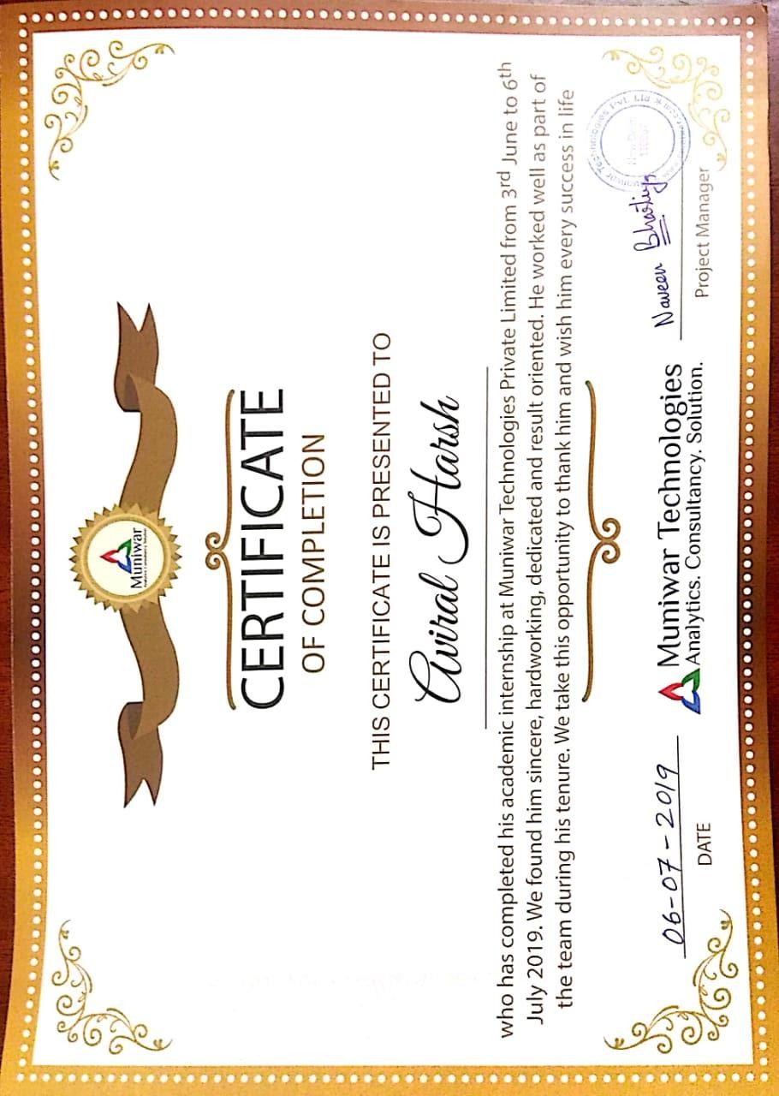



# School of Computing Sciences and Engineering BONAFIDE CERTIFICATE

### This is to certify that the on-site Industrial Internship Report entitled

**“Project Manager & Web Developer”** submitted by **Vaibhav Agrawal (17BCE1076)** to VIT University - Chennai Campus, in partial fulfilment of the requirement for the award of the degree of **Bachelor of technology** in **Computer Science and Engineering** is a record of bonafide internship undertaken by him/her fulfills the requirements as per the regulations of this institute and in my opinion meets the necessary standards for submission. The contents of this report have not been submitted and will not be submitted either in part or in full, for the award of any other degree or diploma in this institute or any other institute or university.

|  |  |  |
| --- | --- | --- |
| (Prof. Christy Jackson) | (Dr. M. Braveen) | (Dr. Justus S) |
| **Proctor** | **Internship coordinator** | **Head of Dept. (B.Tech CSE)** |
|  |  | Date: |

**Examiner (s) Signature**

**1. 2.**

**ACKNOWLEDGEMENT**

Internship has an important role in a shaping up an engineering student for practical knowledge how a keeping him update with latest technology. First of all, I would like to express my gratitude towards **Mr. Naveen Bhartiya (CEO, The HOBNOB LLC.)** for his guidance throughout the training. With great pleasure I want to take this opportunity to express my heartfelt gratitude to all the people who helped in making this internship a grand success.

I am highly indebted to the dean of CSE **Dr. R. Jagadeesh Kannan** for giving me the permission to carry out this Internship.

Last but not the least, I express my sincere thanks to **Ms. Akansha (Project Lead, The HOBNOB LLC.) and Mr. Abhishek (Team Leader, Muniwar Technologies pvt. Ltd.)** for the experience that I gained during my internship.

I would like to thank the other Team Members of **The HOBNOB** for sharing their knowledge with me.

Place: Chennai Aviral Harsh

(17BCE1076)

## ABSTRACT

The progressive advance of technology has seen an increase in businesses moving from traditional to digital platforms to transact and communicate with consumers. Convenience through technology is carried out by businesses by implementing Web Technologies techniques on their digital platforms. Some examples of websites technology are like Amazon, Flipkart, Wallmart and Google.

As projects are important to business success and the success or failure of a project partly depends on who manages it, assigning a project to a project manager is therefore among the strategic decisions in project management. Despite its importance, literature on project manager assignment is rather limited. In practice, with the resource constraints faced by a typical organization, making appropriate assignment decisions can be challenging. This challenge is even more paramount in a setting where project managers lead multiple, concurrent projects. Strategically speaking, management should assign projects to project managers in such a way that the assignments enhance the accomplishment of the organization’s strategic objectives. This paper introduces a strategic aspect of project manager assignment. It starts with the discussion on the significance and challenges of making assignment decisions. Based on extensive research, a process including the criteria for project manager assignment is discussed. The paper also provides an overview of an optimization-based methodology for project manager assignment. Future research is suggested.

In my internship, I developed a website with some great features to help the user to track his activity. The first one was a timeline in which the user gets a hold on his recent actions like job applying. The second one was the **“media-kit”** in that the user can make his resume from our provider templates and also a **“visiting card”**. These two systems were then integrated together to provide a better and interactive features to help user. Other works done during the internship include web and data scrapping, reading and saving data.

#### TABLE OF CONTENTS

|  |  |  |
| --- | --- | --- |
| **Chapter** | **Title** | **Page** |
|  | Declaration | i |
|  | Certificate of completion | ii |
|  | Bonafied Certificate | iii |
|  | Acknowledgement | iv |
|  | Abstract | vi |
| 1. | The HOBNOB | 1 |
| 2. | Dynamic Timeline | 4 |
| 3. | Media-Kit | 5 |
| 4. | Results | 11 |
| 5. | Conclusions and Further works | 16 |

**CHAPTER 1**

**The HOBNOB**

**About**

We are a start up a company ‘The Hobnob’ LLC.

Our goal is to provide upcoming influencer, makeup artists and photographers with the maximum exposure to ace in the industry and to help them reach their maximum potential.

We also provide our expertise to brands to set foot in the industry by providing financial and legal guidance to strengthen the core of their company in addition with branding and legal expertise to boost their sales to a level that they have never imagined of.

The journey to accomplish the goal may not be easy, but we make this journey smooth and efficient.

HOBNOB is the one stop destination where you can achieve all this fast and efficient. We plan to give our influencer partners a lifetime of Resources that will help them achieve ease success.

We are Head Quatered in new Delhi and have an Expert team of Digital marketers, Web Designers, Strategists, Graphic Designers, Content Developers and many more

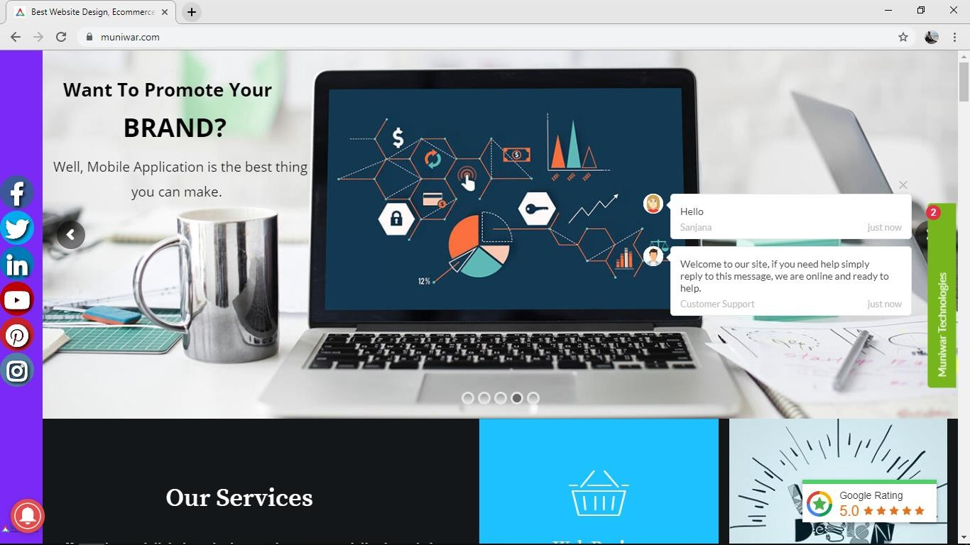

Fig 1: Latest Snip of the Website

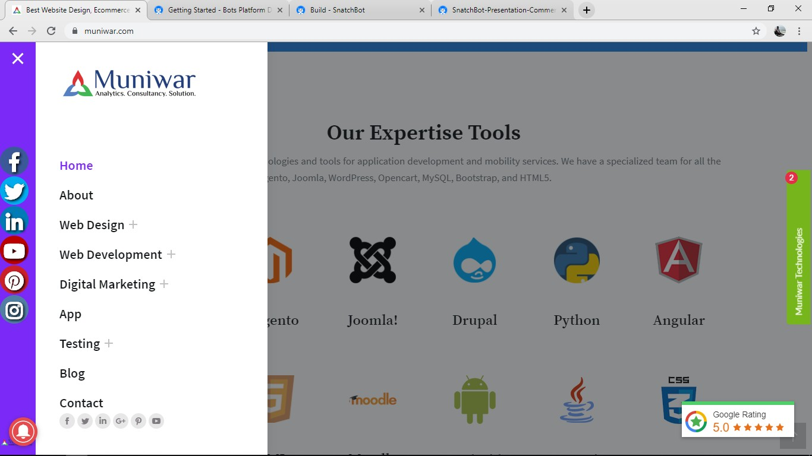

Fig 2: Platforms where Muniwar Technology work

## CHAPTER 2

**Features**

* 1. **Dynamic Timeline:**
* **Easy To use:** In the website there will be a tab provided when the user login they see a journey tab in that they can see in how many jobs the have applied in the past, and all the status about the jobs .
* **Woking:** It tracks the user data all the surfing and searching the user is making in this profile according to that our system recommend them jobs which the can apply some will be direct apply and some will redirective after applying our system fetch the data from the company profile like its image, Name, About, estimate pay etc. And then it gets updated to the user journey section.

**Media-Kit**

**About:**

The Media-kit has following two different features:

* Resume Builder
* Visiting Card Builder

**Resume:**

In the resume section we provide a form to fill up the basic details of the user which will be used to make their resume. Resume builder gives user very friendly interface, user can select from bunch of templates like casual, professional, cv etc.

**Visiting card Builder:**

In the Visiting Card section we provide a form to fill up the basic details of the user which will be used to make their VC. VC builder gives user very friendly interface, user can select from bunch of templates like casual, professional, cv etc.

**Social Media Scheduler calendar**

A social media scheduling tool is an automation tool that helps you schedule social media posts for multiple social media accounts ahead of time. You can't be active by yourself on social media all the time, so using a social media scheduler helps you be proactive.

Most social media scheduling tools are fully loaded with features such as publishing, analytics, moderation, and team collaboration. But, only a few of them successfully offer all the functionalities that you and your team are looking for, and we certainly understand that.

You are not alone. We all have been there. That is the pressing question where most people scratch their heads. Deciding the best social media scheduling tool for your team is certainly not easy!

In this blog, we are going to introduce you to some of the most popular social media scheduling and publishing tools and an insightful list of their pros and cons to make it easy for you. Hang on- we have more; we have added a comparison list of every feature to make it easy for you to select the social media posting tools that supercharges your social media management activities.

## CHAPTER 3

**Architecture and Framework:**

Web Application Architecture is a framework that is comprised of the relationships and interactions between application components, such as middleware systems, user interfaces, and databases. The general concept of Web Application Architecture is in line with the concept of a browser user who triggers an application that is capable of running in multiple websites.

In essence, Web Application Architectures can be defined with the depiction of this process:

A user browses for a specific URL, which the browser locates and requests.

Over the network, data is sent from the server to the browser, then executed by the browser so that it is able to display the requested page.

The user views and interacts with the page.

As explained by DZone, Web Application Architecture includes all sub-components and external application interchanges for an entire software application.

As the tech world continues to evolve, applications are considered a spearhead in this transformational process. Modern application architecture and its development are continuously improving in both of its frontend and backend capabilities.

Nowadays, having an online presence also means being mobile as more and more web access originates with mobile devices. Mobile application architecture plays a key role in how developers approach client requirements to ensure there are consistency and availability across all platforms. As more complexity is added to applications, developers, in turn, become less specialized in covering multiple development skills. Full stack development architecture embodies a significant volume of information and tools that piece together a web application.

## CHAPTER 4

**Result and Conclusion:**

The implementation of all the applications that were designed during the internship were done using web languages like HTML,CSS,JAVASCRIPT and for the backend work we used MongoDB, php, sql etc.

## CODES:

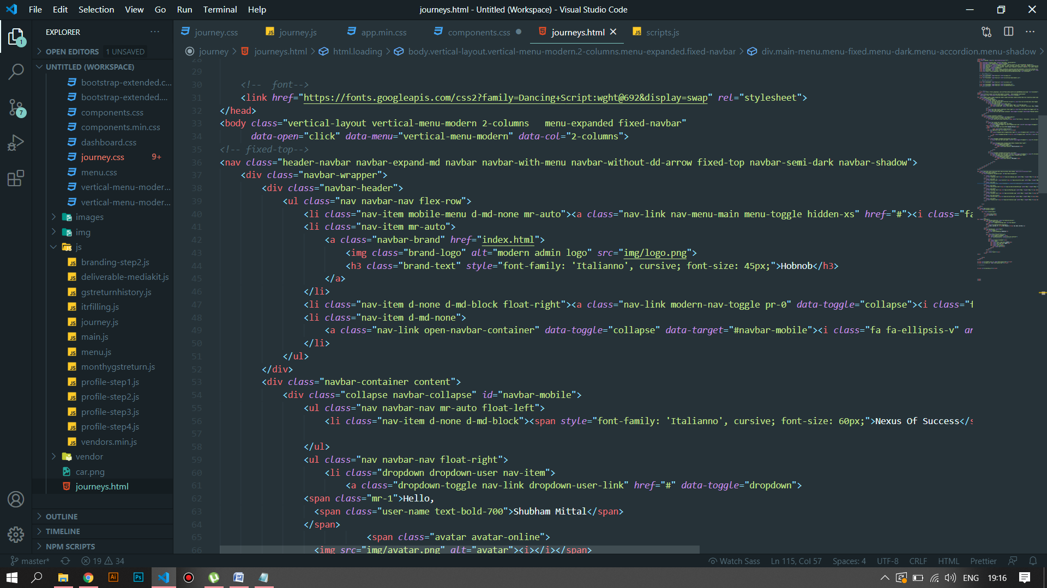

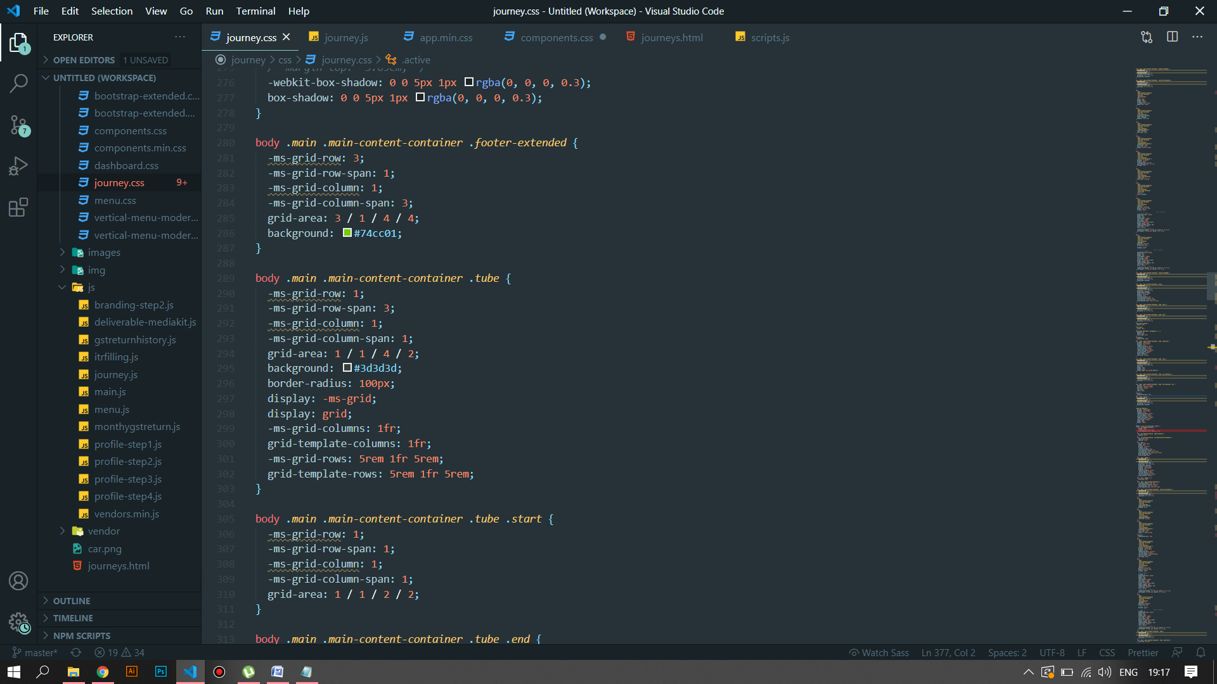

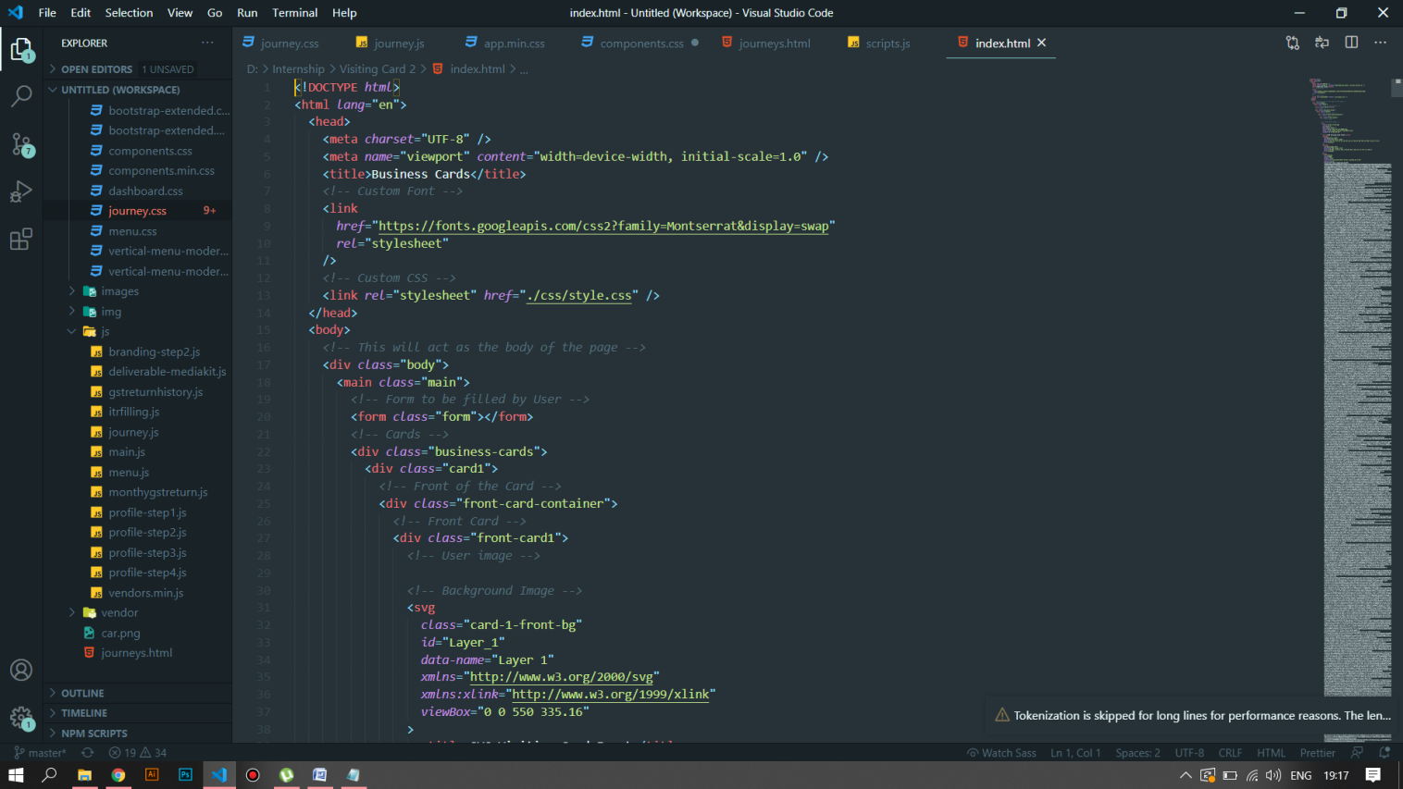

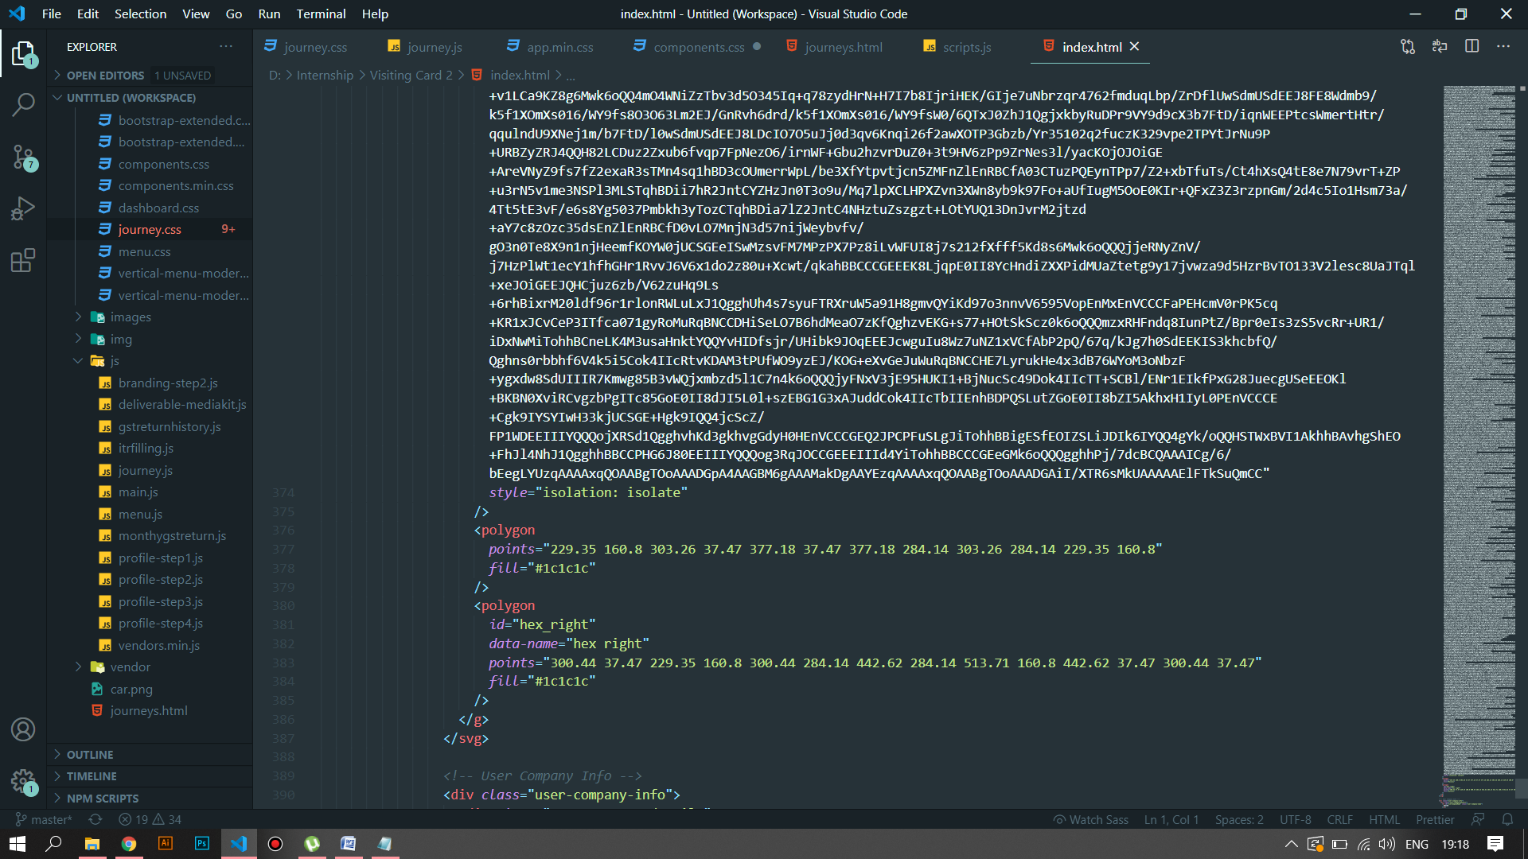

## CHAPTER 5

**Final Result:**

The systems hence made not just reduced the time required for answering common queries to a lot of customers but also saved a lot of cost overhead for the company. The features of the system are listed below.

* Workload reduced.
* Time saved.
* User friendly and easy to operate.
* Improve Service

## CHAPTER 6

**Conclusion and Future Work:**

So, by this project we can conclude that marketing automation can increase the productivity of a company significantly. By this internship I have learnt a lot about the how the things in a corporate office work, how MNC’s operate and how to plan and mange project workload.

In future these solutions can be greatly improved. The things that can be improved are listed below.

* We can run another recommendation system layer based upon a CF which will further improve the user experience.
* Other social media platforms can be also used for integrating chat-bot and increase digital footprint.
* Text-to-Speech options can be added to the chat-bot for more interactive outputs.
* The chat-bots’s interface could be upgraded to a graphical interface.

